ChamberFest Cleveland:
an interview with violinist/violist Yura Lee

by Jarrett Hoffman
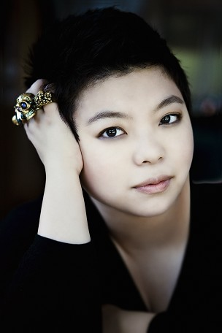
The first concert in season four of Franklin and Diana Cohen’s ChamberFest Cleveland begins on Wednesday, June 17 at 8:00 pm in SPACES Gallery. This year’s theme is “Crossing Borders” — borders including those of geography, culture, style, mood, and career path. We caught up with violinist/violist Yura Lee, a veteran of the festival, who will be performing on the first five concerts (June 17, 18, 19, 21, 23) as well as the tenth and final concert on July 1. See our interview with the Cohens for details about each concert.
Yura Lee is the winner of the only first prize awarded across the four categories in the 2013 ARD Music Competition in Munich. The recipient of the prestigious Avery Fisher Career Grant, she is also currently a member of the Chamber Music Society of Lincoln Center as both violinist and violist.

Last week, Lee was at the Spannungen festival in the small town of Heimbach, Germany. With almost no Internet connection and spotty phone reception there, she graciously agreed to answer questions by email.

Jarrett Hoffman: How did you come to be a professional violinist and violist?

Yura Lee: I picked up the violin when I was 4 years old and started playing professionally by age 9. As for viola, I always liked it. I began teaching myself around age 15 and later studied with teachers. My first public performance on the instrument was actually with Diana Cohen! It was at the Marlboro Festival in 2006, where we played Kodaly’s Serenade for two violins and viola. I was very happy to share that experience again with Diana in last year’s ChamberFest.

JH: What’s it like to switch back and forth between the instruments?

YL: You have to become an absolutely different person, both physically and mentally. I love the challenge.

JH: Violin or viola — which is your favorite?

YL: I can’t choose, and that’s why I play both!

JH: How long have you known Frank and Diana Cohen?

YL: I’ve known Diana for at least 20 years, I think. I met Frank later. Both are such lovely, creative people, and what they have going with the festival is fantastic. It’s all about celebrating the joy of music with people you love. Every year is another great year.

JH: What does it mean to be performing on the concert honoring Frank?

YL: I’m so happy to get to celebrate for him and with him. And to play one of the greatest pieces in the chamber music repertoire, Brahms’s Clarinet Quintet, is such a privilege.

JH: Three days after the Spannungen festival, you’ll be playing five ChamberFest concerts in seven days, plus the final concert on July 1. How do you get through such busy times performing?

YL: This kind of life is normal for me. In Heimbach I’m playing at least one different piece every night, and some of them are completely new. My normal day consists of some sleep, rehearsals from usually 8am until night, and a concert — and then partying and dinner, of course!

JH: Any thoughts on the repertoire at this year’s ChamberFest?

YL: I think each piece is unique, and most if not all the pieces being played at ChamberFest every year could be considered masterpieces. Some are better-known than others, but that’s exactly why people should come to every concert — to discover new pieces and renew their love for what they know.

Published on ClevelandClassical.com June 15, 2015.
Click here for a printable copy of this article
Return to the Front Page.

