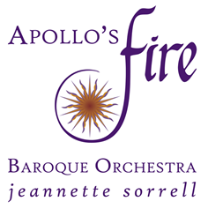

CONTACT: Nichole Fehrman, Director of Marketing & Community Engagement
nfehrman@apollosfire.org
216.320.0012 ext. 4

FOR IMMEDIATE RELEASE
Apollo’s Fire is pleased to announce
The 2025-2026 Season
Jeannette Sorrell, Artistic Director
TICKETS & SUBSCRIPTIONS ON SALE NOW
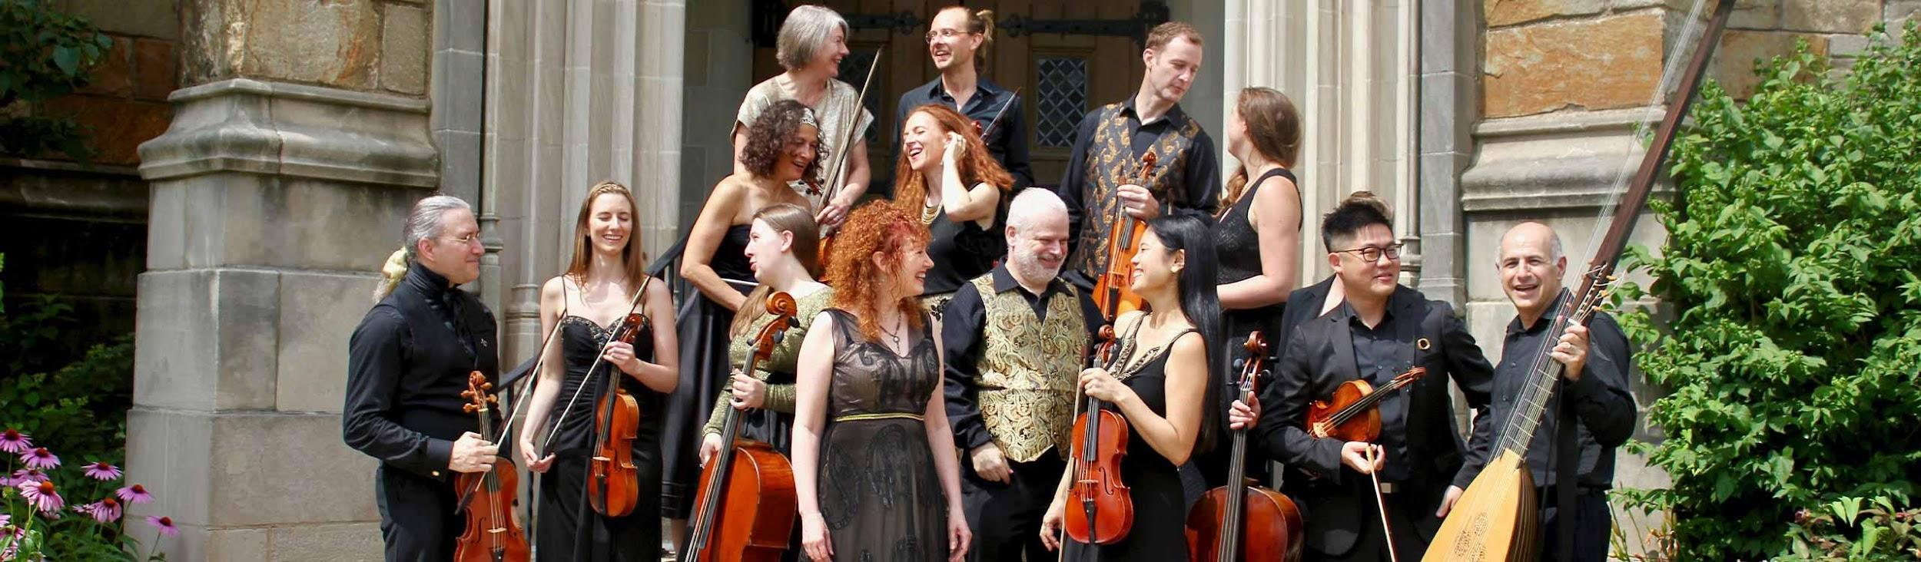

“Brimming with energy and imagination…”
– BBC MUSIC MAGAZINE
Apollo's Fire, the GRAMMY-winning baroque orchestra based in Cleveland, announces their 34th season under Artistic Director Jeannette Sorrell. Highlights of the 2025-2026 include a return to Severance Music Center for Mozart’s glorious Requiem, performances of the acclaimed multicultural program O Jerusalem!, a mini-residency at St. Martin-in-the-Fields in London (including a collaboration with members of the world-renowned English Baroque Soloists), and an international CD release of Bach’s B Minor Mass.
Programming includes music by Bach, Vivaldi, Purcell, Lully, and Rameau, and will feature AF’s youth choir, Apollo’s Musettes, in the December holiday concerts of Praetorius Christmas Vespers.
AF also continues serving the community through its Community Access Initiative, including free in-school workshops for children in public schools, free weekend Family Concerts, and $12 “Presto Seats” at subscription concerts. The Community Access Initiative has served over 50,000 youth and adults in Northeast Ohio.
STORIES FOR OUR TIME
Apollo’s Fire is known for its distinctive, “storytelling” approach to historical baroque and folk music. Storytelling is a hallmark of the 2025-26 season, which opens with a theatrical concert presentation of Purcell’s opera Dido and Aeneas, exploring dramatic themes of love and betrayal. In November, Apollo’s Fire gathers 70 of the nation’s finest period-instrument specialists and early music singers to bring Mozart’s masterful Requiem to life at Severance Music Center (also, at the stunning St. Bernard Church in Akron).
After holiday performances of the enchanting Christmas Vespers, Apollo’s Fire lights “Winter Sparks” with a program of virtuoso showpieces from Bach, Vivaldi, and more – and then takes audiences to France with a program inspired by King Louis XIV, who was known to dress as Apollo the Sun-God.
Finally, Apollo’s Fire pays tribute to the vibrant cultures of the Middle East in a fresh, new version of Jeannette Sorrell’s acclaimed program, O Jerusalem! – Crossroads of Three Faiths. Hailed as “a voyage of faith for the 21st century… a triumph” (Seen & Heard International), this program also became an acclaimed CD release in 2022, with critics writing:

“Captivating… a ravishing musical landscape… gorgeous and stylish.”
– ClevelandClassical.com

“Brims with energy and imagination… programmed with real vision – a mesmerising portrait of Old Jerusalem.”
– BBC Music Magazine, 2022

“Gripping immediacy… a timely, sumptuous and refreshing vision of peace.”
– Gramophone Magazine, 2022

NATIONAL & INTERNATIONAL TOURING
Apollo’s Fire will perform over a dozen national concerts on tour this season, including concerts in New York City as well as Illinois, Ohio, Indiana, Florida, Virginia, and the Ravinia Festival (Chicago). A highlight of the season is AF’s return to the famous St. Martin-in-the-Fields in London in April 2026, after a triumphant debut there in 2023. This London “Mini-Residency” will feature three distinct programs:
- FENCING MATCH: Apollo’s Fire vs. The Brits!, Friday, April 24: A musical duel between Apollo’s Fire and members of the world-renowned English Baroque Soloists – all led by Jeannette Sorrell. Not to be missed!
- BAKLAVA BASH: A Middle Eastern Celebration, Friday, April 24 (Late-Night Bistro Concert in the Crypt): Israeli recorder virtuoso Daphna Mor and Palestinian-American oud master Ronnie Malley join friends Alan Choo, Emi Tanabe, and Tina Bergmann to evoke a Middle Eastern café in 1700.
- O JERUSALEM! – Crossroads of Three Faiths, Saturday, April 25: The troupe of 26 international artists brings Jeannette Sorrell’s acclaimed program to London’s most beautiful baroque venue. A memorable night!
More information about upcoming tour performances may be found at apollosfire.org/touring/touring-schedule/.
CD ALBUM & VIDEO RELEASES
Apollo’s Fire will release a new CD album of Bach’s B Minor Mass in November on British label AVIE. This much-anticipated recording is based on the concerts led by Jeannette Sorrell in Northeast Ohio and Chicago in April 2025, praised as “easily one of the most memorable musical evenings in recent years” (Chicago Classical Review).
AF’s new full-length video of Handel’s Messiah, also under Sorrell’s direction, will be released in December. Filmed at Cleveland’s stunning Trinity Cathedral last winter, this video will be available initially on Medici-TV and later on YouTube.

TICKETS & SUBSCRIPTIONS
Subscriptions and Single Tickets for the 2025-2026 season are now available online or by phone at 216.320.0012 x 1.
Prices range from $25-85 for single tickets, with discounts available for students, young adults, and seniors. Subscriptions start at $93 for 4 concerts or $132 for the entire season. $12 Presto Seats, with seat assignments chosen by the box office, go on sale (by phone only) 3 weeks before each subscription performance.
$10 Student tickets are reserved seats. Alternatively, youth under 18 and full-time college students with student ID are eligible for FREE Student Rush Tickets, 30 minutes before the concert, contingent on seating availability.

2025-2026 SUBSCRIPTION SERIES: SEASON OVERVIEW

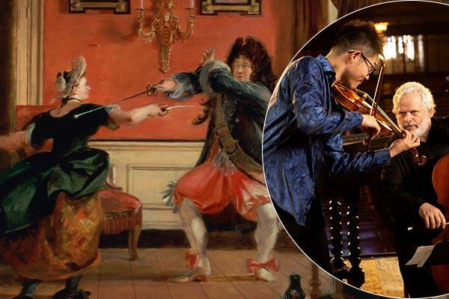
LATE SUMMER NIGHTS
Fencing Match: Round One
August 8-10

Late summer nights are for passion, romance, and sometimes… fiery duels. Join us for a red-hot concert of dueling double-concertos by Vivaldi, Dall’Abaco, J.S. Bach, and Telemann. This evening of dazzling agility features Alan Choo and Susanna Perry Gilmore in Bach’s Double Violin Concerto, as well as René Schiffer and Rebecca Landell in Vivaldi’s stormy Concerto for Two Cellos. Flautists Kathie Stewart and Daphna Mor steal the thunder with Telemann’s Concerto for Flute and Recorder, with its famous Polish folk-inspired finale.

Friday, August 8, 7:30pm – The BATH Church (UCC)
Saturday August 9, 3:00pm and 7:30pm – Harkness Chapel, UNIVERSITY CIRCLE
Sunday, August 10, 4:00pm – ROCKY RIVER Presbyterian

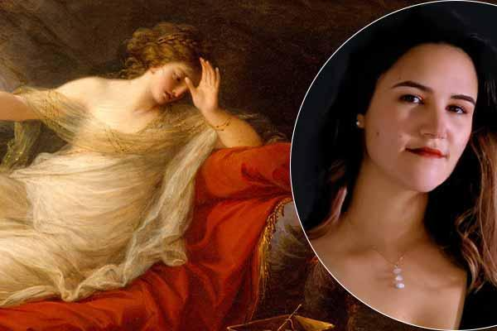
Program #1:
Purcell’s DIDO & AENEAS
October 3 & 9-12

Aryssa Leigh Burrs, mezzo-soprano (Dido)
Edward Vogel, baritone (Aeneas)

Dido and Aeneas, the ancient Roman myth of love and betrayal, was recounted 2000 years ago in Virgil’s Aeneid – and still resonates today. The Trojan hero Aeneas lands on the shores of Carthage, where the beautiful and proud Queen Dido reigns. Just after winning her love, Aeneas suddenly departs – summoned by the gods. Was it destiny or betrayal? No composer has evoked this question with more poignancy than Henry Purcell, whose renowned 17th-century opera Dido & Aeneas is a gem of the baroque repertoire. The program includes sparkling instrumental dances from Purcell’s King Arthur and Faery Queen.

Friday, October 3, 7:30pm – Greystone Hall, AKRON
Thursday October 9, 7:30pm – Morley Hall, Lake Erie College, PAINESVILLE
Friday, October 10, 7:30pm – The Tudor Arms Hotel, CLEVELAND
Saturday, October 11, 7:30pm – Kulas Hall, CLEVELAND Institute of Music
Sunday, October 12, 4:00pm – Gamble Auditorium, Baldwin Wallace, BEREA

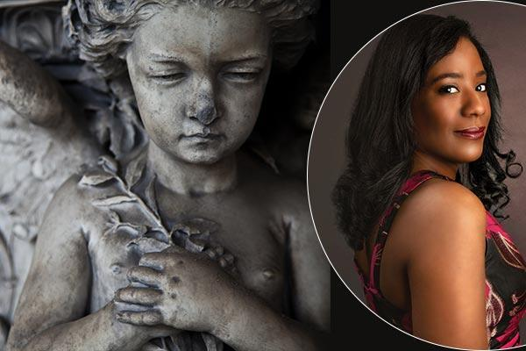
Program #2:
Mozart REQUIEM + Eric Gould: 1791: Requiem for the Ancestors (World Premiere)
November 7-8

Jeannette Sorrell, conducting
Sonya Headlam, soprano | Guadalupe Paz, mezzo-soprano
Jacob Perry, tenor | Kevin Deas, bass-baritone

Against the backdrop of worldwide unrest and revolution, Mozart composed his masterful Requiem in 1791 – as aspirations for democracy were unfolding in France, Haiti, and the American colonies. At the same time, economic forces were creating a personal crisis for Mozart – a situation that resonates for so many people today. Apollo’s Fire is thrilled to revisit Mozart’s Requiem alongside a world premiere by composer Eric Gould. 1791: Requiem for the Ancestors evokes the neglected voices of African, Caribbean, and Native American peoples from the time of Mozart’s Requiem. Jeannette Sorrell leads 70 of the nation’s finest period-instrument specialists and early music singers in these concerts.

Friday, November 7, 7:30pm – St. Bernard’s, AKRON
Saturday, November 8, 7:30pm – SEVERANCE HALL, CLEVELAND

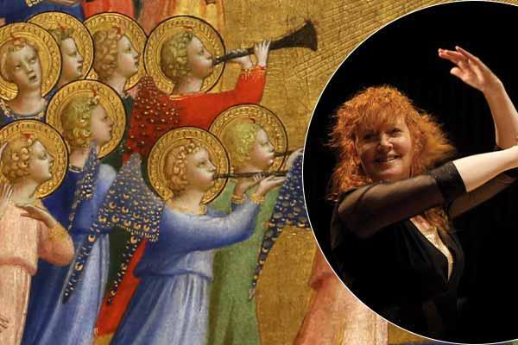
Program #3:
Praetorius CHRISTMAS VESPERS
December 12 & 18-21

Praised as “a sheer delight” (NEW YORK TIMES), Apollo’s Fire’s acclaimed Christmas program returns! Artistic Director Jeannette Sorrell weaves the extraordinary works of 17th-century composer Michael Praetorius into a Vespers service. The cathedral resounds in a splendor often reminiscent of Monteverdi – with antiphonal choirs, trumpets, sackbuts, cornettos, lutes, harp, strings and recorders. Familiar highlights include “Lo, how a Rose e’re blooming” and “In Dulci Jubilo.” Children’s voices shine in this haunting and joyous celebration of the Christ child..

“Charged with Apollo’s Fire’s signature energy… a spark that grows into a blaze.”
– GRAMOPHONE

Friday, December 12, 7:00pm – St. Paul’s Episcopal, AKRON
Thursday, December 18, 7:00pm – Trinity Cathedral, CLEVELAND
Friday, December 19, 7:00pm – Trinity Cathedral, CLEVELAND
Saturday, December 20, 7:00pm – First Baptist Church, SHAKER HEIGHTS
Sunday, December 21, 4:00pm – St. Raphael Catholic Church, BAY VILLAGE

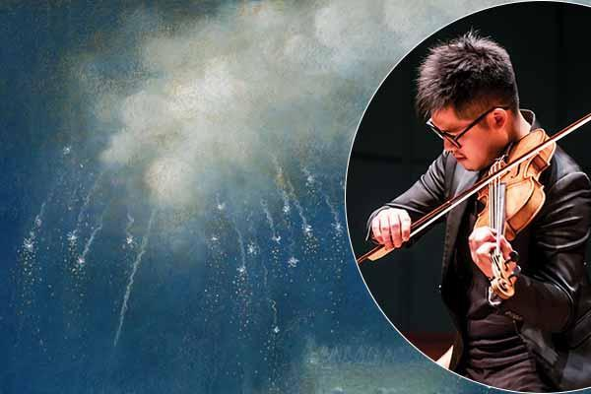
Program #4:
WINTER SPARKS from Bach & Vivaldi
January 29 – February 1

In this cozy winter program, eight Apollo’s Fire musicians set sparks flying in virtuoso works of J.S. Bach, Telemann, Vivaldi, and more. Flautist Kathie Stewart takes the spotlight in a chamber performance of Bach’s brilliant Orchestral Suite (Ouverture) No. 2, while Debra Nagy steals the thunder in a lively Vivaldi oboe concerto. Violinist Alan Choo and viola da gambist HyunKun Cho face off in Marais’ Sonnerie, an imaginative showpiece imitating the sounds of bells from a famous church in Paris.

Thursday, January 29, 7:30pm – First United Methodist Church, CUYAHOGA FALLS
Friday, January 30, 7:30pm – St. Paul’s Church, CLEVELAND HEIGHTS
Saturday, January 31, 7:30pm – Federated Church, CHAGRIN FALLS
Sunday, February 1, 4:00pm – ROCKY RIVER Presbyterian

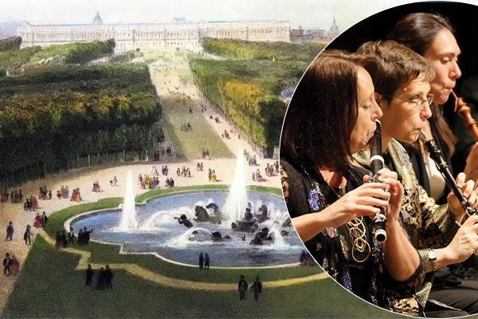
Program #5:
Palace of VERSAILLES
March 5-8

Apollo’s Fire visits the palace of Louis XIV – the Sun King, who was known to dress as our muse Apollo. The gorgeous music of Lully, Marais, and Rameau shows the orchestra at its finest. Flutes and theorbos join the strings in the sumptuous program full of the majesty of 17th-century France.

Thursday, March 5, 7:30pm – St. Paul’s Episcopal, AKRON
Friday, March 6, 7:30pm – St. Paul’s Episcopal, CLEVELAND HEIGHTS
Saturday, March 7, 7:30pm – St. Paul’s Episcopal, CLEVELAND HEIGHTS
Sunday, March 8, 4:00pm – ROCKY RIVER Presbyterian

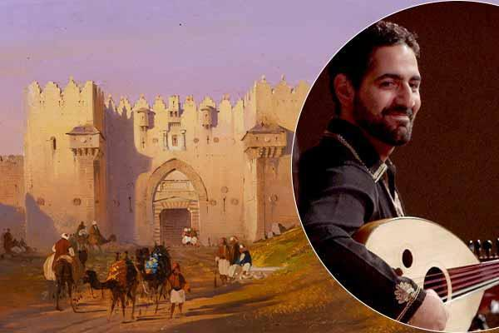
Program #6:
O JERUSALEM! Crossroad of Three Faiths
April 9-11

Hailed as “a ravishing musical landscape… a sensory feast” (ClevelandClassical.com), this evocative program created by Jeannette Sorrell rings with urgency in our time. An ensemble of 26 artists from Jewish, Palestinian, Muslim, and Christian backgrounds come together in this loving tribute to the peoples whose music and faith brought such vibrancy to the Middle East.

In this musical tour of the four quarters of Old Jerusalem (Jewish, Christian, Arab, and Armenian/Byzantine), surprising cross-influences emerge. A Sabbath prayer leads to a Sephardic ballad of a lover betrayed; selections from Monteverdi’s great Vespers of 1610 echo the exotic and rapturous singing of the Jewish cantors in the temples; a classical Arabic love song leads poignantly into the wild Longa Farahfaza – an instrumental romp. The rhythms of daily life – love, singing, dancing and prayer – culminate in a joyous celebration of shared humanity.

“On period instruments, a voyage of faith for the 21st century… Apollo’s Fire continues to challenge and enchant. The entire evening was delivered with urgency, polish, and flair. To hear an ensemble at the peak of their powers, making vital statements about the world, is a privilege.”
– Seen & Heard International, 2018

Thursday, April 9, 7:30pm – The BATH Church (UCC)
Friday, April 10, 7:30pm – CLEVELAND Museum of Art
Saturday, April 11, 7:30pm – Congregation Mishkan Or (The Temple-Tifereth Israel), BEACHWOOD

SPECIAL TOUR SEND-OFF CONCERT
Fencing Match: Round Two
April 16

Inspired by the 18th-century tradition of instrumentalists facing off in friendly yet breathtaking displays of skill, Apollo’s Fire principal players step into the spotlight with double-concertos by Bach, Vivaldi, and more. Repeating a few favorites from Round 1, and adding some daring surprises in Round 2, this will be an evening of dazzling agility among playful friends. This program heads to London following the local performance!

Thursday, April 16, 7:30pm – AVON LAKE United Church of Christ

JEANNETTE SORRELL, ARTISTIC DIRECTOR

“Sorrell is an absolute dynamo onstage and a pleasure to see conduct….
a force to be reckoned with.”
– SAN FRANCISCO CLASSICAL VOICE

"Sorrell led a splendid performance. Wonderful vitality... lithe, glowing and elegant.
It's difficult for a “Messiah” performance to stand out. But this one did."
– THE NEW YORK TIMES, Anthony Tommasini, chief critic
(review of Messiah with New York Philharmonic), 2021

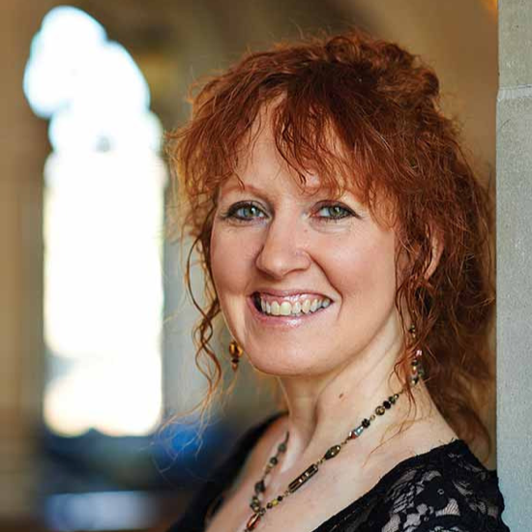
GRAMMY®-winning conductor Jeannette Sorrell is recognized internationally as one of today’s most compelling interpreters of Baroque and Classical repertoire. She is the subject of Oscar-winning director Allan Miller’s documentary, PLAYING WITH FIRE: Jeannette Sorrell and the Mysteries of Conducting, commercially released in 2023.
Bridging the period-instrument and symphonic worlds from a young age, she studied conducting under Leonard Bernstein, Roger Norrington and Robert Spano at the Tanglewood and Aspen music festivals; and studied harpsichord with Gustav Leonhardt in Amsterdam. She won First Prize in the Spivey International Harpsichord Competition, competing against over 70 harpsichordists from four continents.
As a guest conductor, Sorrell made her New York Philharmonic debut in 2021 to rave reviews and returned in 2023. She has repeatedly conducted the Pittsburgh Symphony, St Paul Chamber Orchestra, Seattle Symphony, Utah Symphony, Florida Orchestra, Philharmonia Baroque in San Francisco, and New World Symphony, and has also led the Philadelphia Orchestra, Royal Scottish National Orchestra, Royal Liverpool Philharmonic, Baltimore Symphony, the National Symphony at the Kennedy Center, Houston Symphony, Los Angeles Chamber Orchestra, Opera St Louis with the St Louis Symphony, the National Arts Centre Orchestra (Ottawa), Calgary Philharmonic (Canada), Royal Northern Sinfonia (UK), and Orquesta Sinfónica de Castilla y León (Spain), among others.
In 2024-25, she makes debuts with the Detroit Symphony and New Jersey Symphony, and returns to the Los Angeles Chamber Orchestra. In 2025-26 she returns to the New York Philharmonic for the third time, and also returns to the Detroit Symphony, Indianapolis Symphony, and The Florida Orchestra; and makes her debut with the Oregon Symphony and the Manchester-Hallé Symphony in the UK. Locally, she will also make her debut with CityMusic Cleveland in a program of Beethoven and Mendelssohn.
As founder and conductor of APOLLO’S FIRE, she has led the renowned ensemble at London’s BBC Proms, Carnegie Hall, and many international venues. Sorrell and Apollo’s Fire have released 30 commercial CDs, including 11 bestsellers on the Billboard classical chart and a 2019 GRAMMY® winner. Her CD recordings of the Bach St John Passion and Vivaldi’s Four Seasons have been chosen as best in the field by the Sunday Times of London (2020 and 2021). Her Monteverdi Vespers recording was chosen by BBC Music Magazine as one of “30 Must-Have Recordings for Our Lifetime” (2022).
With over 20 million views of her YouTube videos, Sorrell has attracted national attention and awards for creative programming. She received an honorary doctorate from Case Western Reserve University and an award from the American Musicological Society.

ABOUT APOLLO’S FIRE

“The U.S.A.’s hottest baroque band”
– CLASSICAL MUSIC MAGAZINE, UK

“Sorrell and her dazzling period band… are incandescent.”
– THE SUNDAY TIMES, LONDON

“Led by a brilliant harpsichordist, Jeannette Sorrell, the ensemble exudes stylish energy – a blend of scholarship and visceral intensity.”
– GRAMOPHONE

Named for the ancient god of music, healing and the sun, Apollo’s Fire is a GRAMMY®-winning ensemble. The period-instrument orchestra was founded by award-winning harpsichordist and conductor Jeannette Sorrell. Dedicated to the baroque ideal that music should evoke the various Affekts or passions in the listeners, Apollo’s Fire brings to life the music of the past for audiences of today, with Passion. Period. The Apollo’s Fire musicians are creative artists who share Sorrell’s passion for drama and rhetoric.
In Europe and the UK, Apollo’s Fire has performed 6 tours including sold-out concerts at the BBC Proms in London, the Aldeburgh Festival (UK), Madrid’s Royal Theatre, St Martin-in-the-Fields, and Bordeaux’s Grand Théàtre de l’Opéra; with concerts at Heidelberg Spring Festival, the Irish National Concert Hall (Dublin), the Irish National Opera House (Wexford), and venues in Germany, France, Italy, Austria, and Portugal. The ensemble has had many live radio broadcasts across Europe. AF’s London 2014 concert was chosen by the DAILY TELEGRAPH as one of the “Best 5 Classical Concerts of the Year,” with their critic writing, “An evening of superlative music-making… the group combines European stylishness with American entrepreneurialism.”

North American tour engagements include Carnegie Hall (2018 and 2022), the Tanglewood Festival (2015, 2017, and 2021), the Ravinia Festival (4 times), the Metropolitan Museum of Art in NY (numerous times), the Boston Early Music Festival series, the Library of Congress, the Aspen Music Festival, Caramoor Festival, and major venues in Toronto, Los Angeles and San Francisco. In 2021, Apollo’s Singers made their debut with the New York Philharmonic under the baton of Jeannette Sorrell, winning rave reviews – with a return engagement in 2023.

At home in Cleveland and Chicago, Apollo’s Fire frequently enjoys sold-out performances at its subscription series, which has drawn national attention for creative programming.

With over 20 million views (total) of its YouTube videos, Apollo’s Fire is one of the most popular baroque orchestras on the worldwide internet. The ensemble also launched a “Worldwide Watch-at-Home Series” in 2020, bringing its subscription concerts into the homes of patrons around the world.

Apollo’s Fire has released 33 commercial CDs and won a GRAMMY® award in 2019 for the album Songs of Orpheus with tenor Karim Sulayman. AF’s recordings of the Bach St John Passion, Vivaldi’s Four Seasons, and the Monteverdi Vespers have been chosen as best in the field by the Sunday Times of London (2020 and 2021) and BBC Magazine (2022). 14 of the ensemble's CD releases have become best-sellers on the classical Billboard chart, including Bach’s Coffeehouse (Billboard Classical #1, 2024), Biber’s Mystery Sonatas (Billboard Classical #2, 2024), Handel’s Israel in Egypt (Billboard Classical #6, 2023), Vivaldi’s Four Seasons (Billboard Classical #2, 2021), the Monteverdi Vespers, Bach's Brandenburg Concertos & Harpsichord Concertos, a disc of Handel arias with soprano Amanda Forsythe titled “The Power of Love” (Billboard Classical #3, 2015), Songs of Orpheus (Billboard Classical #5, 2018), and five of Jeannette Sorrell’s multicultural programs: Come to the River – An Early American Gathering (Billboard Classical #9, 2011); Sacrum Mysterium – A Celtic Christmas Vespers (Billboard Classical #11, 2012); Sugarloaf Mountain – An Appalachian Gathering (Billboard Classical #5, 2015); Sephardic Journey – Wanderings of the Spanish Jews (Billboard World Music Chart #2 and Billboard Classical #5, 2016); and Christmas on Sugarloaf Mountain (Billboard #3, 2018).

For additional photos or videos, please contact Nichole Fehrman at 216.320.0012, ext. 4, or nfehrman@apollosfire.org.

